Lenna with 2D Gaussian of sigma 1
Lenna with 2 1D Gaussian of sigma 1
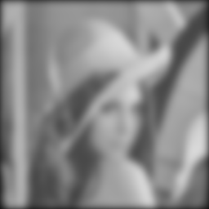Lenna with 2D Gaussian of sigma 5
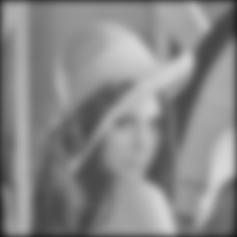Lenna with 2 1D Gaussian of sigma 5
Original Lenna.pgm

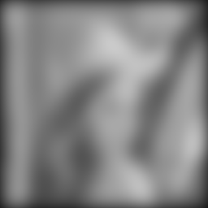Lenna with 2D Gaussian of sigma 11
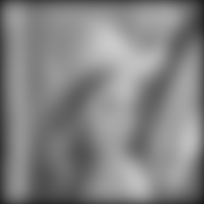Lenna with 2 1D Gaussian of sigma 11

Original Lenna.pgm
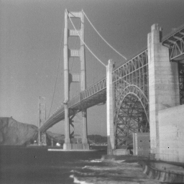Original SF.pgm
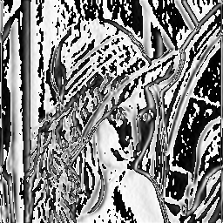Lenna after masked with Sx
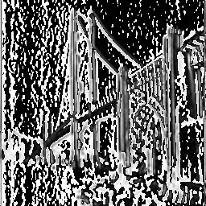SF after masked with Sx
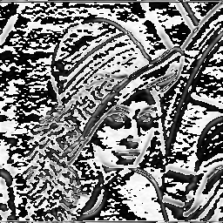Lenna after masked with Sy
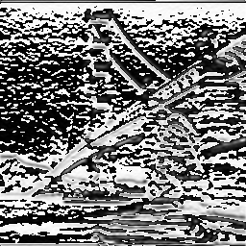SF after masked with Sy

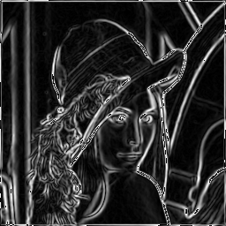Magnitude of Lenna
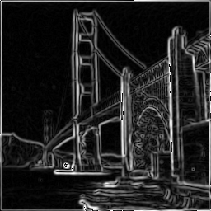Magnitude of SF
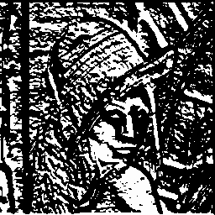Lenna after applying the directional gradient
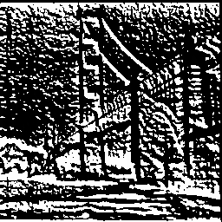SF after applying the directional gradient
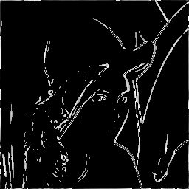The magnitude of Lenna after setting a threshold of 150
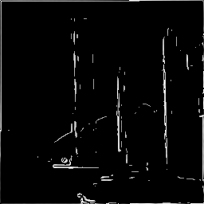The magnitude of SF after setting a threshold of 150

Original Lenna
Lenna at 128 pixels and smoothed (1/4th size original)
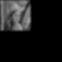Lenna at 64 pixels (1/16th size)
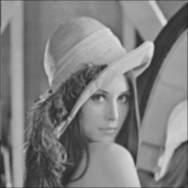Lenna at 256 pixels and smoothed

